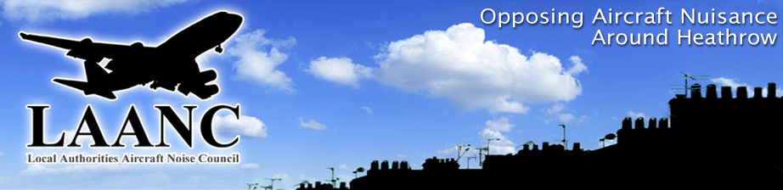

President Mr Michael Elliot
Chairman Councillor Malcolm Beer
Director. Colin Stanbury
Website: http://www.laanc-heathrow.org.uk/ M 07778 294309

MINUTES OF

THE LOCAL AUTHORITIES’ AIRCRAFT NOISE COUNCIL
COUNCIL MEETING
HELD AT
SPELTHORNE BOROUGH COUNCIL OFFICES,
KNOWLE GREEN, STAINES, MIDDX
Commencing at 10.30am
on
FRIDAY 9th March 2018

The Chairman welcomed all of the members to the Council Meeting.
GERRY CEASER:
The Chairman announced the recent death (24th February 2018) of Mr Gerry Ceaser (Vice President). At the Chairman’s request those present stood for 1minute’s silence in respect.
The Chariman reminded those present that Gerry’s contribution to public life had been immense and had encompassed may roles including being both a former Leader and Mayor of Spelthorne Council. Together with his wife Zandra he fulfilled the key coordinator role for LAANC for a number of years. In this role Gerry and Zandra provided admin support, coordinated meetings, provided secretarial services, liaised with Spelthorne regarding meeting room provision and support services, as well representing LAANC on HACC.
It was agreed unanimously that LAANC would make a financial contribution to a charity to be nominated by Zandra.
1 | THOSE IN ATTENDANCE:  Mr Paul Baker, Hammersmith and Fulham, Hillingdon, Cllr. Malcolm Beer, R.B. Windsor & Maidenhead, (Chairman),Mr John Coates, L.B Richmond, Dr Margaret Majumdar, ENAG (Vice president), Mr Colin Stanbury Director. Mr Peter Willan, Richmond Heathrow Campaign (RHC).  Observers: Mr Nigel Davis (minutes),
2. | APOLOGIES  Mrs Val Beale, Hillingdon, Mr Robin Clarke, NATS, Mr Gareth Harper, Independent, Cllr Wendy Matthews, Iver Parish Council, Cllr June Nelson, Hillingdon, Mr Arun Sood, Treasurer, Dr. Chris Hill, Mr Michael Elliot (President), Mrs June Nelson, L.B. Hillingdon, Cllr M Ellengorn, L.B. Richmond, Cllr Howard Thomson, Splethorne B.C. Mr Chris Nash, RB Windsor and Maidenhead, Mr Suri Surinderpol. L.B Hounslow, Cllr Monica Davis Datchet Parish Council Cllr. Fiza Matloob, Slough BC.
3. | MINUTES OF PREVIOUS MEETING  The Minutes of the Executive meeting (19th January 2018) having been circulated were noted. The minutes of the 8th December 2017 Council Meeting were also noted.
4. | MATTERS ARISING  There were none from either set of minutes.
5. | LAANC – FUTURE ADMIN ARRANGEMENTS  Colin Stanbury to provide temporary cover, but hope that Rob Gibson, ex officer in Hounslow Council, will take over the admin support role.  Colin and John to approach Rob regarding acceptance of admin role for LAANC. He will not be asked to fulfill any external representative functions for LAANC.  Malcolm to contact Howard Johnson (vice chair LAANC), current member of Spelthorne, regarding ongoing room and service provision for LAANC.  Zandra Ceaser believed to have booked room provision with Spelthorne through to the end of 2018. Colin to confirm.  Malcolm also to approach Terry Collier, chief officer at Spelthorne, regarding on going provision of accountancy services for LAANC, including management of cash balances, collection of subscriptions and provision of annual accounts.  Meeting agreed that Colin would take over the LAANC representative role on HACC, which is currently being morphed into the ‘Heathrow Community Engagement Board’. New chair appointed but not identified. First meeting of HCEB scheduled for 18th April.  John Bowden from RBWM community member on HCEB, with Chris Nash and Malcolm to be nominated deputies.  Heathrow Strategic Planning Group, with chair Brendon Walsh, acting as liaison group with relevant LAs regarding Heathrow planning approval via the DCO. LAANC has not appointed a representative – for further consideration.  Heathrow Community Noise Forum - Malcolm to be nominated as LAANC representative.
6. | HEATHROW EXPANSION  No 3rd Runway Coalition advice is not to reply to the first HAL consultation on either expansion or Airspace change.  No response to HAL consultation from the four LAs challenging decision, although legal response to be submitted.  Meeting agreed that LAANC would respond to HAL consultation, with focus on noise impacts. Colin to produce and circulate draft response by email, although 29th March deadline makes this challenging timescale.  Hammersmith & Fulham L.B confirmed they will be responding to HAL consultation but on basis that they DO NOT SUPPORT EXPANSION. PB kindly offered to send CS a working draft of their proposed response.  Parliamentary Transport Subcommittee report on the Draft Airports NPS anticipated by the end of March.
7. | TRAFFIC STATS  Airport passenger figures for January 2018 circulated. These show a 2.8% rolling year passenger expansion at Heathrow.
8. | AOB  There was none  The Meeting closed at 1pm

DATES OF THE NEXT MEETING
Executive Meeting: 27th April
Council Meeting: 8th June.

