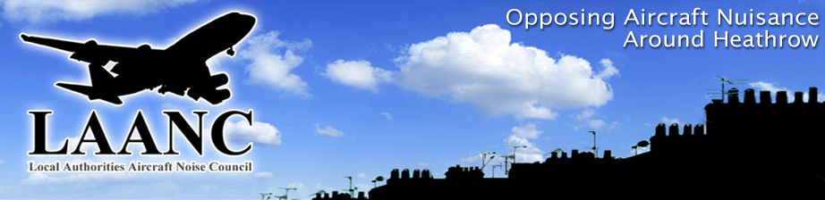

President Mr Michael Elliot
Chairman Councillor Malcolm Beer
Director. Colin Stanbury
Website: http://www.laanc-heathrow.org.uk/ M 07778 294309

MINUTES OF

THE LOCAL AUTHORITIES’ AIRCRAFT NOISE COUNCIL
EXECUTIVE MEETING
HELD AT
SPELTHORNE BOROUGH COUNCIL OFFICES,
KNOWLE GREEN, STAINES, MIDDX
Commencing at 10.30am
on
FRIDAY 27th April 2018

1 | THOSE IN ATTENDANCE:  Mr Paul Baker, Hammersmith and Fulham, Hillingdon, Cllr. Malcolm Beer, R.B. Windsor & Maidenhead, (Chairman), Mrs Val Beale, L.B Hillingdon, Mr John Coates, L.B Richmond, Dr Margaret Majumdar, ENAG (Vice president), Mr Colin Stanbury Director. Mr Peter Willan, Richmond Heathrow Campaign (RHC), Dr Chris Hill (independent), Cllr. Howard Thomson, Spelthorne B.C. Cllr Wendy Matthews, Iver Parish Council  Observers: Mr Nigel Davis, Mr Rob Gibson (independent). The Chair welcomed Rob Gibson to the meeting and hoped that he would be able to assist LAANC in the coming months having regard to his experience and knowledge in aviation and environmental issues.
2. | APOLOGIES  Mr Gareth Harper, Independent, Cllr June Nelson, Hillingdon, Mr Arun Sood, Treasurer, Mr Michael Elliot (President), Richmond Mr Chris Nash, RB Windsor and Maidenhead, Mr Suri Surinderpol. L.B Hounslow
3. | MINUTES OF PREVIOUS MEETING  The Minutes of the Executive meeting (19th January 2018) although having been stated circulated were unable to be located (Director to action). The minutes of the 8th March 2018 Council Meeting were also noted.
4. | MATTERS ARISING  Some corrections were made to the Council Meeting Minutes (March 2018). These were:  Meeting agreed that The Director would take over the nominated LAANC representative role on HACC, which is currently being morphed into the ‘Heathrow Community Engagement Board’. New chair appointed and now named as Ms. Rachel Cerfontyne  Colin Stanbury to be nominated LAANC representative on HCEB, with Malcolm Beer and Dr. Margaret Majumdar to be nominated deputies.  It was noted that the first meeting of HCEB took place on 18th April 2018.  Link to minutes of HCEB: https://www.hceb.org.uk/meetings  Heathrow Strategic Planning Group, with chair Brendon Walsh, are acting as liaison group with relevant LAs regarding Heathrow planning approval via the DCO. LAANC has not appointed a representative for further consideration. After discussion it was agreed that LAANC would not apply to join this group as there were strong indications that the group is being funded by HAL. Val Beale agreed to check the financial status of the HSPG.  Heathrow Community Noise Forum – The Chair of LAANC (Cllr. Malcolm Beer) to be nominated as LAANC representative.
5. | LAANC - FUTURE ADMIN ARRANGEMENTS  On – going discussion with Rob Gibson..  The Director confirmed that all meeting dates on the LAANC factsheet for 2018 have been booked (thanks to Spelthorne B.C.)  Director has also been able to confirm with Terry Collier (chief officer at Spelthorne B.C) agreement to continue provide accountancy services for LAANC, including management of cash balances, collection of subscriptions and provision of annual accounts.
6. | HEATHROW EXPANSION  The Director confirmed that LAANC had responded to the HAL consultation (now closed). The response was submitted using the HAL on line consultation link. The Director undertook to try to retrieve a copy of the LAANC submission for the next meeting.
7. | TRAFFIC STATS  Airport passenger figures for February 2018 circulated. These show a 2.0% year on year passenger & atms expansion at Heathrow. London wide 11.56 million passengers used the 6 No. “London Airports” in February 2018. Southend airport is now classified as being within the London System and this has shown a 30% year on year growth in passengers (February 2017 – February 2018 = + 30%). The airport is however still a minor player in the London system (980 atms for February 2018).
8. | AOB  There was none  The Meeting closed at 1pm

DATES OF THE NEXT MEETING
Council Meeting: 8th June 2018.

